# Faga’alu stokes drift

## From Vetter (unpublished)

**Wave and Tide Observations**

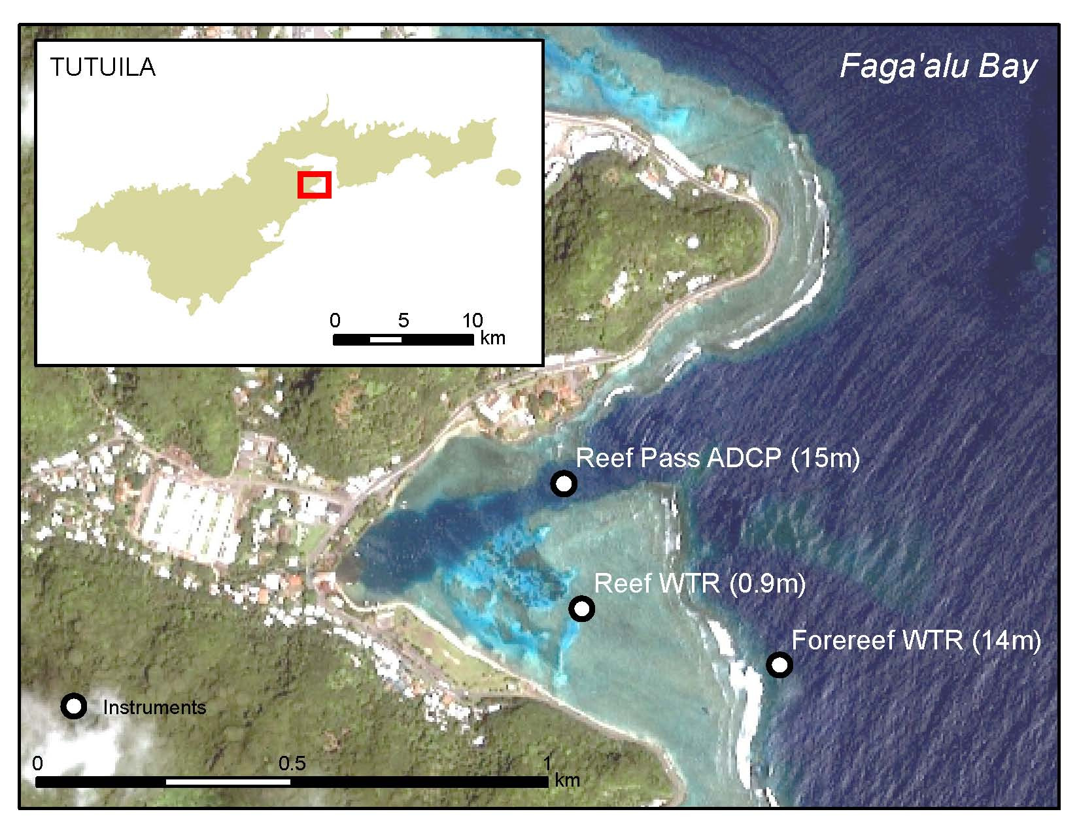

**Figure 1**. Geographic setting and oceanographic instrumentation deployments between April 2012 & April 2013 in and around Faga’alu Bay, American Samoa

Waves and tides were recorded in the bay and on the forereef (Figure 2A). The incident wave field was a relatively weak wave forcing, compared with other forereef areas around the Pacific. Over the time period of data collection (9th April 2012 to 2nd April 2013), significant wave height peaked at 1.7m, although wave heights > 1m were rarely observed. The sheltered position of the bay, in the mouth of the natural harbor, means that the bay is only open to a narrow swell window. South swells then have to refract west to hit the reef directly, reducing their energy further. Reef flat wave heights were orders of magnitude smaller than the incident waves due to the strong attenuation after breaking over the shallow reef; a typical result for shallow reef regions. Since the water depth at the reef crest is almost zero at low tide, cross-reef transport of water and waves are completely dependent on the tidal range and wave setup. Significantly greater wave energy can transport across the reef at high tide compared with low (Figure 2 A & B).

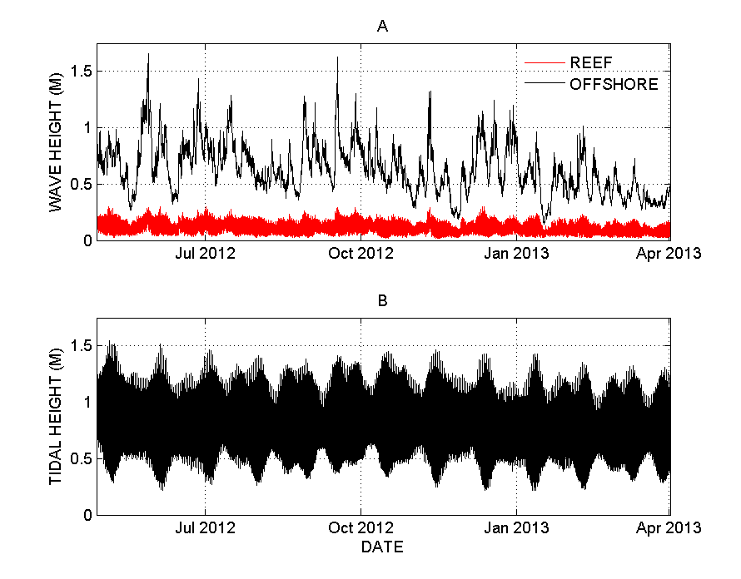

So max wave height recorded was 1.7m at the reef crest. Max wave height on the reef flat, relatively far away from the reef crest, was approximately 0.25 m at the most, and only during high tide.

Stoke’s Drift is calculated: (http://diginole.lib.fsu.edu/cgi/viewcontent.cgi?article=1016&context=uhm)

|  |  |  |
| --- | --- | --- |
|  | $$U_{Stoke}= \frac{π^{2}H^{2}}{L^{2}}c\frac{\cos{h\left(2k\left(h-z\right)\right)}}{sin{ h}^{2}\left(k h\right)}$$ |  |
| where H is wave height, L is wavelength, c is wave speed, z is depth below the surface *k* is the wave number (2π/L) and *h* is the water depth. | | |

Calculated Stokes Drift for the max wave height observed by Oliver Vetter 2013-2014. Looks like it’s probably not Stokes Drift, since it’s at most 0.51 cm/s. However, if the wave height is 0.5 m and period was 4 sec, then Stokes Drift on the reef flat is ~2 cm/s so could be important during strong trades?

|  |  |  |  |  |  |  |  |  |  |  |  |  |
| --- | --- | --- | --- | --- | --- | --- | --- | --- | --- | --- | --- | --- |
|  | from Vetter | assumed from WW3 data | L (m) = 1.56T^2 | c (m/s) = 0.62 * sqrt(L) | assumed | k = 2pi/L | from Vetter |  |  |  |  |  |
|  | Wave Height m | Wave Period sec | Wave Length m | Wave Speed m/s | depth below surface m | Wave number | Water depth m | pt 1 | pt2 | pt3 | Stokes Drift m/s | Stokes Drift cm/s |
|  | H | T | L | c | z | k | h | (pi^2 H^2)/L^2 | c | cos h (2k (h-z)) / sin h^2 (k h) | pt1 * pt2 * pt3 | * 100 |
| Reef Crest | 1.7 | 8 | 99.84 | 6.195038 | 0.1 | 0.062933 | 14 | 0.002861465 | 6.19503801 | 0.28899666 | 0.00512 | 0.51 |
| Reef Flat | 0.25 | 8 | 99.84 | 6.195038 | 0.1 | 0.062933 | 0.9 | 6.18829E-05 | 6.19503801 | 1.525754462 | 0.00058 | 0.06 |